# Shell Script Assignment

**Mandatory:**

1. Create a script named “myscript” in current directory to do the following.
2. display “hello user”

Ans: In myscript type echo “hello user” and run the program

1. list files in current directory

Ans: ls

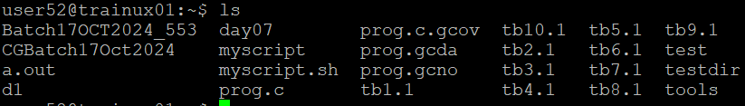

1. name of logged in user

Ans: whoami

1. date

Ans: date

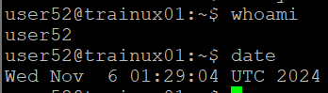

1. Add execute permission and Run the script from
2. current directory

Ans: chmod 0755 myscript.sh



1. Create a subdirectory named “test”

Ans:

1. Change to “test” directory. Run the script “myscript” [Hint: You will have to update PATH to include the directory containg script to run script from any location].